**Pract: 6 : COmpund Statements**

1. create table emp(emp_no varchar(5), name varchar(20), city varchar(20), state varchar(20), salary number(10,2));  
   INSERT INTO emp VALUES('&no','&name','&city','&state',&sal);  
   Insert 8 values.  
   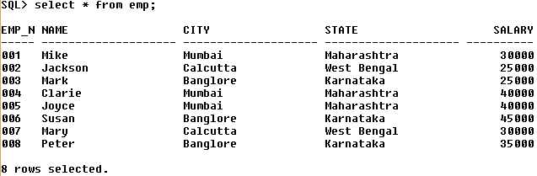
2. List emp name and city whose city is Mumbai and Sal is > 30000.  
   Select name, city from emp where city = 'Mumbai' and salary > 30000;

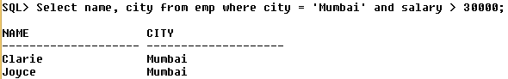

1. List employee name and salary whose salary is between 25000 and 35000.  
   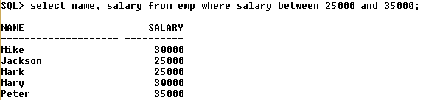
2. List the rows whose name starts with m  
   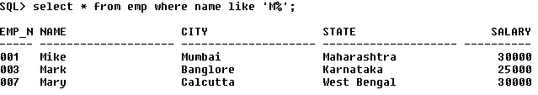
3. List the rows whose name starts with c and ends with e  
   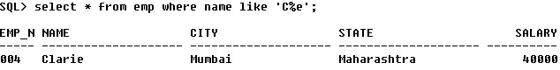
4. List the rows where name starts with M and having three characters after it.  
   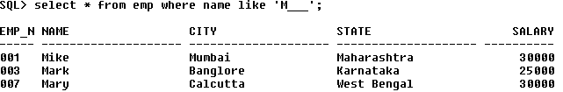
5. List emp_no , name and salary of those employees whose name does not starts with J.  
   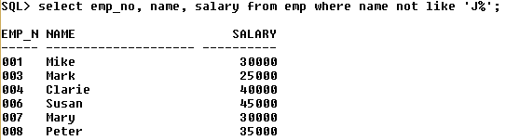
6. List the records form the table whose name does not end with ‘E’  
   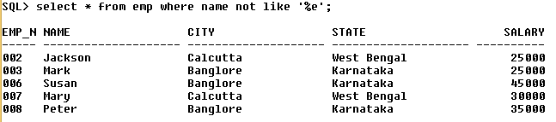
7. Retrieve the rows of the employees which is not between 004 and 007  
   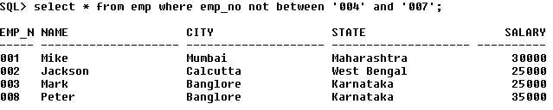
8. List emps whose emp_no are 001,005 and 008.  
   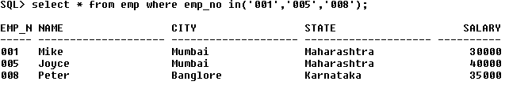
9. Retrieve the rows whose emp_no is not 001 and 002 and does not belong to the city Banglore.  
   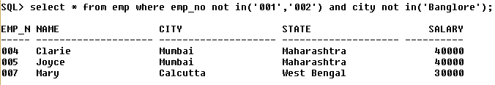
10. Retrieve the rows whose emp_no is not 001 and 002 OR does not belong to the city Banglore.  
    